**BANK LOAN ANALYSIS REPORT**

**Q1.Total Loan Application**

SELECT COUNT(id) AS Total_Loan_Applications

FROM bank_loan_data;

**OUTPUT:**

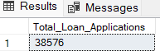

**Q2.MTD Loan Application**

SELECT COUNT(ID) AS MTD_Application

FROM bank_loan_data

WHERE MONTH(issue_date) = 12 AND YEAR(issue_date) = 2021;

**OUTPUT:**

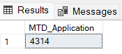

**Q3.PMTD Loan Application**

SELECT COUNT(ID) AS PMTD_Application

FROM bank_loan_data

WHERE MONTH(issue_date) = 11 ;

**OUTPUT:**

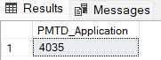

**Q4.Total Funded amount**

SELECT SUM(loan_amount) AS Total_Funded_Amount

FROM bank_loan_data

**OUTPUT:**

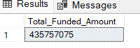

**Q5.Total Funded amount (MTD)**

SELECT SUM(loan_amount) AS MTD_Total_Funded_Amount

FROM bank_loan_data

WHERE MONTH(issue_date) = 12 AND YEAR(issue_date) = 2021

**OUTPUT:**

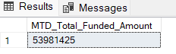

**Q6.Total Funded amount (Previous MTD)**

SELECT SUM(loan_amount) AS PMTD_Total_Funded_Amount

FROM bank_loan_data

WHERE MONTH(issue_date) = 11 AND YEAR(issue_date) = 2021

**OUTPUT:**

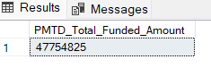

**Q7. Total Amount Received**

SELECT SUM(total_payment) As Toatal_Amt_Received

FROM bank_loan_data;

**OUTPUT:**

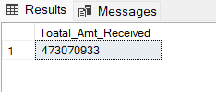

**Q8. Total Amount Received (MTD)**

SELECT SUM(total_payment) As Toatal_Amt_Received_MTD

FROM bank_loan_data

WHERE MONTH(issue_date)= 12 AND YEAR(issue_date) = 2021;

**OUTPUT:**

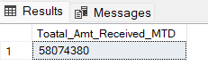

**Q9. Total Amount Received (PMTD)**

SELECT SUM(total_payment) As Toatal_Amt_Received_PMTD

FROM bank_loan_data

WHERE MONTH(issue_date)= 11 AND YEAR(issue_date) = 2021;

**OUTPUT:**

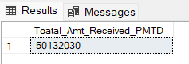

**Q10. Average Interest Rate**

SELECT AVG(int_rate)*100 AS AVG_Interest_Rate

FROM bank_loan_data;

**OUTPUT:**

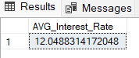

**Q11. Average Interest Rate(MTD)**

SELECT ROUND(AVG(int_rate), 4)*100 AS AVG_Interest_Rate_MTD

FROM bank_loan_data

WHERE MONTH(issue_date) = 12 AND YEAR(issue_date) = 2021;

**OUTPUT:**

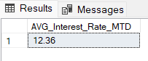

**Q12. Average Interest Rate(PMTD)**

SELECT AVG(int_rate)*100 AS AVG_Interest_Rate_PMTD

FROM bank_loan_data

WHERE MONTH(issue_date) = 11 AND YEAR(issue_date) = 2021;

**OUTPUT:**

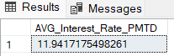

**Q13. AVG DTI**

SELECT ROUND(AVG(dti), 4)*100 AS Avg_DTI

FROM bank_loan_data;

**OUTPUT:**

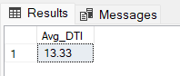

**Q14. MTD AVG DTI**

SELECT ROUND(AVG(dti), 4)*100 AS MTD_Avg_DTI

FROM bank_loan_data

WHERE MONTH(issue_date) = 12 AND YEAR(issue_date) = 2021;

**OUTPUT:**

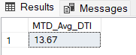

**Q15. PMTD AVG DTI**

SELECT ROUND(AVG(dti), 5)*100 AS PMTD_Avg_DTI

FROM bank_loan_data

WHERE MONTH(issue_date) = 11 AND YEAR(issue_date) = 2021;

**OUTPUT:**

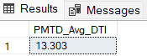

**## Good Loan**

**Q16. Good Loan Percentage**

SELECT

(COUNT(CASE WHEN loan_status = 'Fully Paid' or loan_status= 'Current' Then id END)*100.0)/

COUNT(id) AS Good_loan_Percentage

FROM bank_loan_data ;

**OUTPUT:**

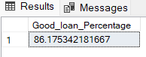

**Q17. Good Loan Applications**

SELECT

COUNT(id) As Good_Loan_Application

FROM bank_loan_data

WHERE loan_status = 'Fully Paid' or loan_status= 'Current';

**OUTPUT:**

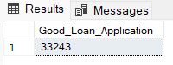

**Q18. Good Loan Funded Amount**

SELECT SUM(loan_amount) As Good_Loan_funded_Amt

FROM bank_loan_data

where loan_status in ('Fully Paid', 'Current')

**OUTPUT:**

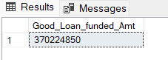

**Q19. Good Loan Amount Received**

SELECT SUM(total_payment) As Good_loan_amt_Received

FROM bank_loan_data

WHERE loan_status in ('Fully Paid', 'Current');

**OUTPUT:**

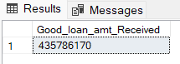

**## BAD LOAN**

**Q20. BAD Loan Percentage**

SELECT COUNT(CASE WHEN loan_status = 'Charged Off' THEN id END)*100.0/

COUNT(id) As Bad_loan_Percentage

FROM bank_loan_data;

**OUTPUT:**

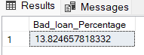

**Q21. Bad Loan Applications**

SELECT COUNT(id) As Bad_Loan_Application

FROM bank_loan_data

WHERE loan_status = 'Charged Off';

**OUTPUT:**

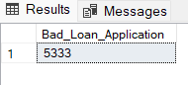

**Q22. Bad Loan Funded Amount**

SELECT SUM(loan_amount) As Bad_Loan_Funded_Amount

FROM bank_loan_data

WHERE loan_status = 'Charged Off';

**OUTPUT:**

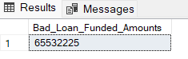

**Q23. Bad Loan Amount Received**

SELECT SUM(total_payment) As Bad_Loan_Amt_Received

FROM bank_loan_data

WHERE loan_status = 'Charged Off';

**OUTPUT:**

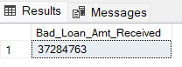

**## LOAN Status**

--Loan Status Details

SELECT

loan_status,

COUNT(id) AS Total_Loan_Application,

SUM(total_payment) AS Total_Amt_Received,

SUM(loan_amount) AS Total_Funded_Amount,

ROUND(AVG(int_rate * 100),2) AS Interest_Rate,

ROUND(AVG(dti * 100),3) AS DTI

FROM

bank_loan_data

GROUP BY

loan_status

**OUTPUT:**

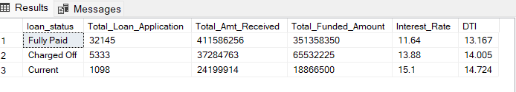

--Loan Status Details By MTD

SELECT

loan_status,

SUM(total_payment) AS MTD_Total_Amount_Received,

SUM(loan_amount) AS MTD_Total_Funded_Amount

FROM bank_loan_data

WHERE MONTH(issue_date) = 12

GROUP BY loan_status

**OUTPUT:**

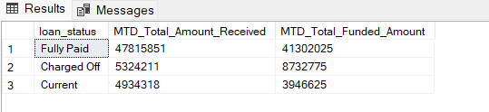

----Loan Status Details By PMTD

SELECT

loan_status,

SUM(total_payment) AS PMTD_Total_Amount_Received,

SUM(loan_amount) AS PMTD_Total_Funded_Amount

FROM bank_loan_data

WHERE MONTH(issue_date) = 11

GROUP BY loan_status

**OUTPUT:**

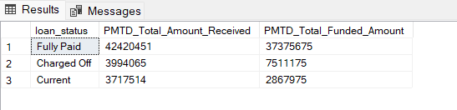

--Monthly Trends

SELECT

MONTH(issue_date) AS Month_Munber,

DATENAME(MONTH, issue_date) AS Month_name,

COUNT(id) AS Total_Loan_Applications,

SUM(loan_amount) AS Total_Funded_Amt,

SUM(total_payment) AS Total_Amt_Received

FROM bank_loan_data

GROUP BY MONTH(issue_date), DATENAME(MONTH, issue_date)

ORDER BY MONTH(issue_date);

**OUTPUT:**

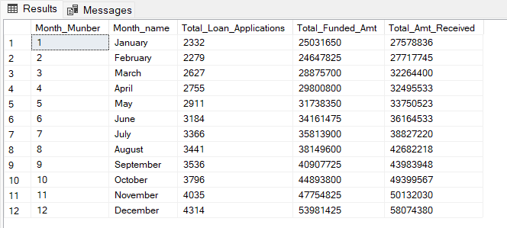

--STATE

SELECT

address_state As State,

COUNT(id) AS Total_Loan_Applications,

SUM(loan_amount) AS Total_Funded_Amt,

SUM(total_payment) AS Total_Amt_Received

FROM bank_loan_data

GROUP BY address_state

ORDER By COUNT(id) DESC;

**OUTPUT:**

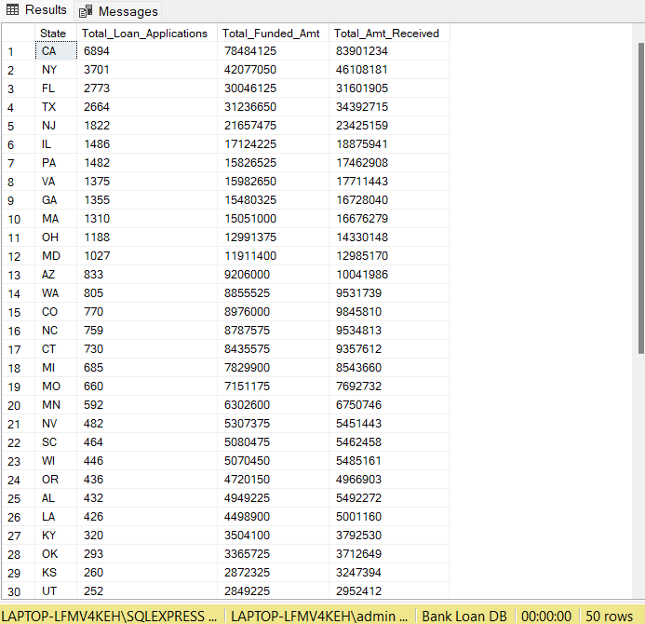

--TERM

SELECT

term,

COUNT(id) AS Total_Loan_Applications,

SUM(loan_amount) AS Total_Funded_Amt,

SUM(total_payment) AS Total_Amt_Received

FROM bank_loan_data

GROUP BY term

ORDER By term ;

**OUTPUT:**

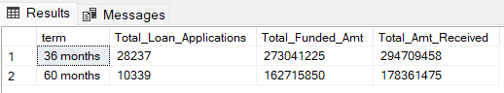

--EMPLOYEE LENGTH

SELECT

emp_length,

COUNT(id) AS Total_Loan_Applications,

SUM(loan_amount) AS Total_Funded_Amt,

SUM(total_payment) AS Total_Amt_Received

FROM bank_loan_data

GROUP BY emp_length

ORDER By COUNT(id) DESC;

**OUTPUT:**

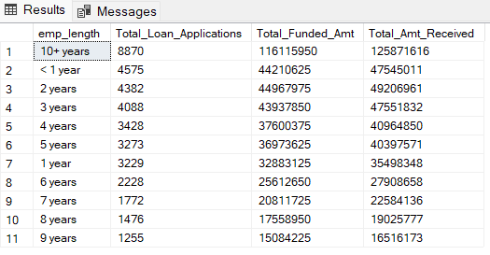

--PURPOSE

SELECT

purpose,

COUNT(id) AS Total_Loan_Applications,

SUM(loan_amount) AS Total_Funded_Amt,

SUM(total_payment) AS Total_Amt_Received

FROM bank_loan_data

GROUP BY purpose

ORDER By purpose;

**OUTPUT:**

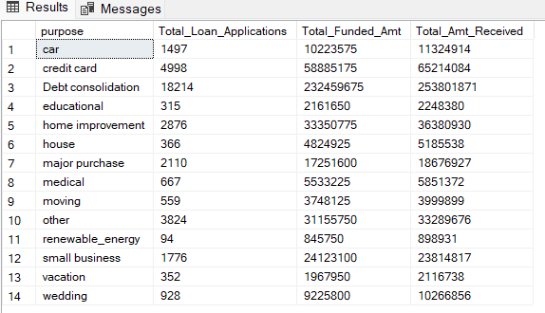

--Home Ownership

SELECT

home_ownership,

COUNT(id) AS Total_Loan_Applications,

SUM(loan_amount) AS Total_Funded_Amt,

SUM(total_payment) AS Total_Amt_Received

FROM bank_loan_data

GROUP BY home_ownership

ORDER By COUNT(id) DESC;

**OUTPUT:**

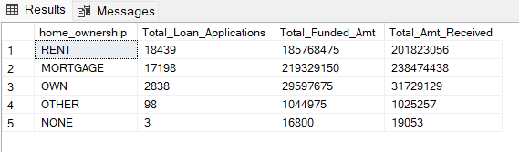

--Applying Filters on different Column

SELECT

home_ownership,

COUNT(id) AS Total_Loan_Applications,

SUM(loan_amount) AS Total_Funded_Amt,

SUM(total_payment) AS Total_Amt_Received

FROM bank_loan_data

WHERE grade ='A' AND address_state = 'CA'

GROUP BY home_ownership

ORDER By COUNT(id) DESC;

**OUTPUT:**

